Enhanced Weather Prediction Model
And
Visualization

-Swikrit Aryal

Introduction
Weather prediction is an essential tool for understanding environmental trends, planning resources, and mitigating risks from extreme weather events. Accurate forecasts can save lives by giving early warnings of storms, heat waves, and disasters. Farmers use them for agricultural management, which can make the difference between a lost harvest or a harvest of plenty (Ritchie & Roser, 2024).
This project leverages machine learning techniques to forecast weather variables such as temperature and precipitation. By evaluating the model’s performance and integrating the data with geographic tools like ArcGIS, we can make informed decisions in areas like disaster preparedness, resource management, and urban planning.
The aim of this project is to:
- Develop a weather prediction model using machine learning.
- Evaluate its accuracy and identify areas for improvement.
- Explore its applications in environmental science and geospatial analysis.

- Datasets:
The datasets were collected from the NOAA website for Shreveport Regional Airport. The dataset used was from 1997-06-01 to 2024-9-30 at the start of this project. The dataset collected had station name, geographic location, rainfall, maximum temperature, minimum temperature, recorded rainfall, etc. Only these data were taken into account as other data provided was not available for making any scientific conjecture, whatsoever.
- Method:
The project followed these steps:
- Data Preprocessing:
  - Missing Values: Missing data in temperature and precipitation columns were addressed using forward filling and statistical techniques.
  - Feature Engineering:
    - Rolling averages and lag variables were added to capture temporal trends.
    - Cyclic features such as sine and cosine transformations were used to encode seasonal effects.
- Model Training:
  - Algorithms Used:
    - Ridge Regression: A linear regression model with regularization to prevent overfitting.
    - Random Forest: A non-linear ensemble model capable of capturing complex patterns.
  - Hyperparameter Optimization:
    - RandomizedSearchCV was applied to fine-tune the Random Forest model’s parameters, improving performance.
- Evaluation and Visualization:
  - Metrics:
    - Mean Absolute Error (MAE): The average absolute difference between actual and predicted values.
    - R² Score: The proportion of variance in the data explained by the model.
  - Residual Analysis:
    - Analyzed the differences between actual and predicted values to identify trends and outliers.
4. Results:
The findings from the model evaluation include:
- Performance Metrics:
  - Ridge Regression:
    - MAE: ~4.51 degrees.
    - R² Score: Demonstrates that the model explained most of the variance.
  - Random Forest:
    - MAE: ~4.47 degrees.
    - R² Score: Slightly better than Ridge Regression, showing
improved accuracy.
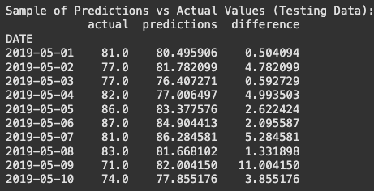
- Examples of Predictions:

- Residual Analysis:
  - Most predictions were within ~5 degrees of actual values.
  - Outliers were identified in extreme weather conditions (e.g., heatwaves or cold spells), suggesting the model struggled with rare events.
- Visualizations:
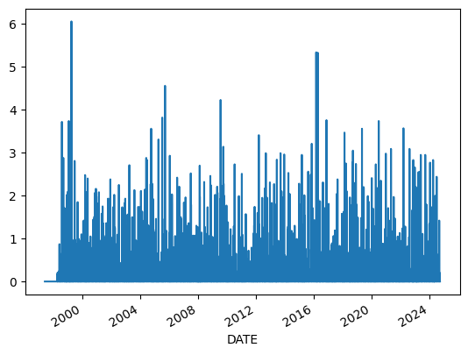
    - A bar chart showing annual rainfall trends.
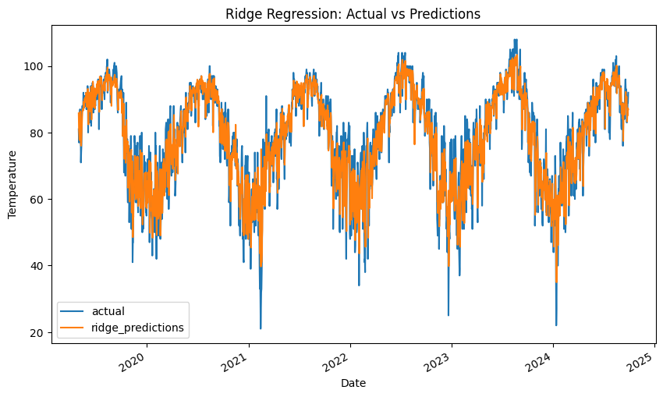
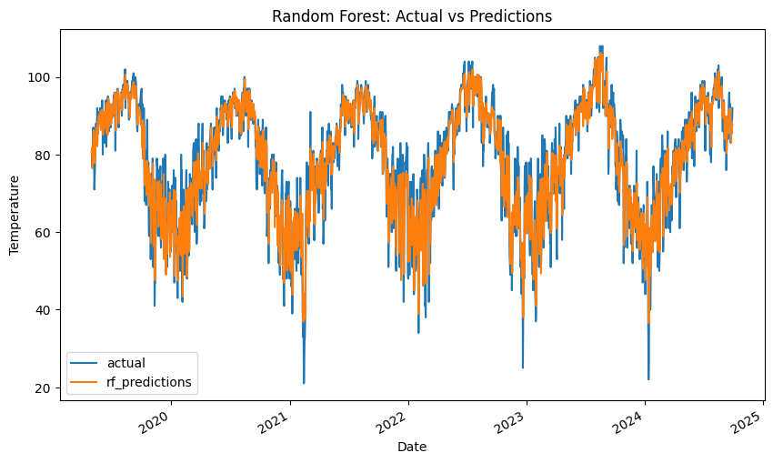
  - A line plot comparing actual and predicted values for the Ridge Regression model and Random Forest models.

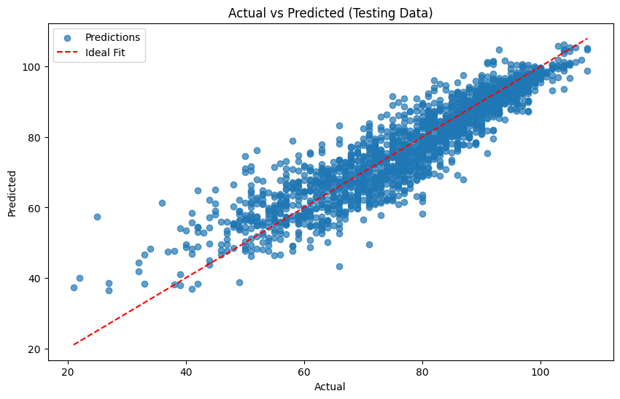
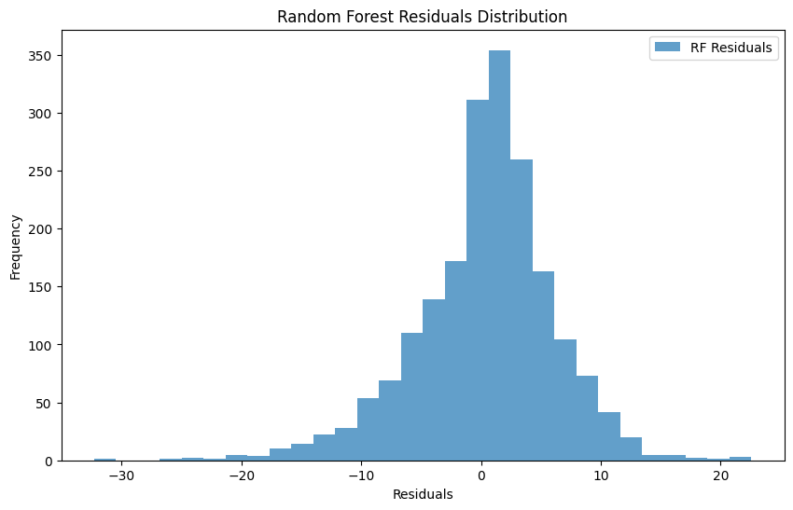
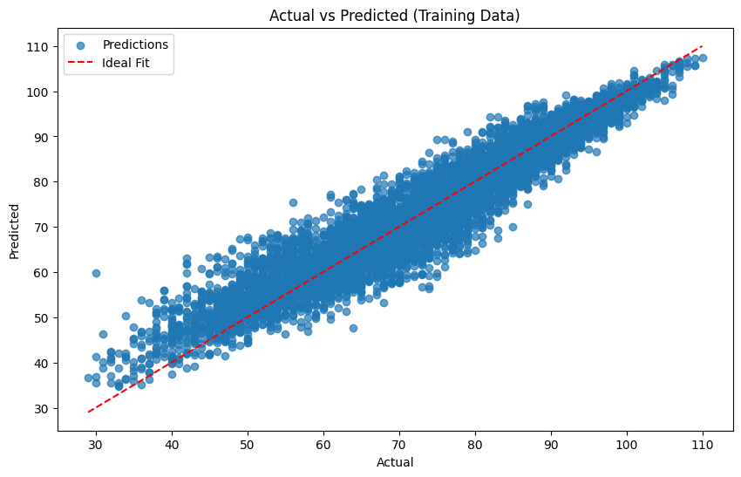
Scatter plot showing improved alignment of predictions with actual values on testing and training data.

5. Why This Data Matters:
The data generated from this model has practical applications across various domains:
- Environmental Monitoring:
  - Identifies long-term climate trends by analyzing historical weather patterns.
  - Tracks seasonal changes that affect biodiversity and ecosystems.
- Disaster Preparedness:
  - Accurate forecasts help anticipate extreme events like floods, droughts, or heatwaves, enabling proactive planning.
- Resource Management:
  - Optimizes water usage for irrigation based on precipitation predictions.
  - Supports energy management by forecasting temperature-dependent demand.
- Urban Planning:
  - Guides infrastructure design to withstand extreme weather conditions.
  - Assists in mapping heat islands and designing green spaces.

6. Improving ArcGIS with This Data:
Integrating weather prediction data into ArcGIS enhances its functionality in several ways:
- Spatial Visualization:
  - Map predicted temperatures and precipitation across regions to identify spatial trends.
  - Use heatmaps to highlight areas prone to extreme weather conditions.(PhD, Bennet)
- Environmental Impact Studies:
  - Combine predicted weather data with layers like population density or vegetation cover to analyze environmental impacts.
  - Model how precipitation patterns influence water bodies or soil erosion.
- Disaster Management:
  - Overlay predicted weather data with floodplain maps to prepare for potential flooding.
  - Analyze wind speed predictions to assess the spread of wildfires or pollutants.
- Urban and Resource Planning:
  - Use precipitation forecasts to manage water resources effectively in urban areas.
  - Incorporate predicted heat trends into city planning to mitigate urban heat islands.
- Temporal Analysis:
  - Use ArcGIS temporal layers to visualize how weather predictions change over time.
  - Animate predicted temperature or precipitation trends to study seasonal effects.

Future Improvements:
To further enhance the accuracy and applicability of this project,
- Data Enrichment:
  - Include additional features like wind speed, humidity, and atmospheric pressure.
  - Incorporate real-time weather data for dynamic predictions.
- Advanced Modeling:
  - Use ensemble models or deep learning techniques for more precise forecasts.
  - Train models on larger and more diverse datasets to capture rare weather events.
- Geospatial Integration:
  - Incorporate geographic features (e.g., elevation, proximity to water bodies) to improve spatial accuracy.
  - Analyze regional variations by clustering areas with similar weather patterns.
- Automation and Scalability:
  - Automate the data pipeline for continuous updates and real-time predictions.
  - Scale the model for global weather predictions using cloud computing platforms.

7. Conclusion:
This project demonstrates the potential of machine learning in weather prediction and its integration with geospatial tools like ArcGIS. Accurate forecasts enable better environmental monitoring, disaster preparedness, and resource management. By addressing current limitations and incorporating advanced techniques, this approach can evolve into a robust system for tackling environmental challenges on a broader scale.

8. Limitations:
It is to be noted that, a seven-day forecast can accurately predict the weather about 80% of the time and a five-day forecast can accurately predict the weather approximately 90% of the time. However, a 10-day + forecast is only 50% accurate. (SciJinks, 2016).

Work Cited:

Ritchie, H., & Roser, M. (2024). Weather forecasts have become much more accurate; we now need to make them available to everyone. Our World in Data. https://ourworldindata.org/weather-forecasts

SciJinks. (2016). How Reliable Are Weather Forecasts? | NOAA SciJinks – All about Weather. Scijinks.gov. https://scijinks.gov/forecast-reliability/

PhD, Lauren Bennett. “Machine Learning in ArcGIS.” Esri, 2 Jan. 2019, www.esri.com/about/newsroom/arcuser/machine-learning-in-arcgis/.

R, Ananth. “WEATHER PREDICTION.” Www.kaggle.com, 2021, www.kaggle.com/datasets/ananthr1/weather-prediction.

‌Datasets:
NOAA. (n.d.). Global Historical Climatology Network (GHCN). National Centers for Environmental Information. Retrieved December 2024, from https://www.ncei.noaa.gov/

OpenWeatherMap. (n.d.). Weather API. Retrieved December 2024, from https://openweathermap.org/api

‌

